QuickDrain USA Kits Streamline
Tub-to-Shower Conversions
Modernize a Shower in Hours, Not Days with Customizable Components
DENVER, SEPTEMBER 10, 2019 — Tub-to-Shower Conversion Kits from QuickDrain USA help contractors adapt to numerous commercial jobsite irregularities, including unexpected plumbing configurations and structural constraints when converting conventional bathtubs into popular spa-like curbless or curbed shower retreats.
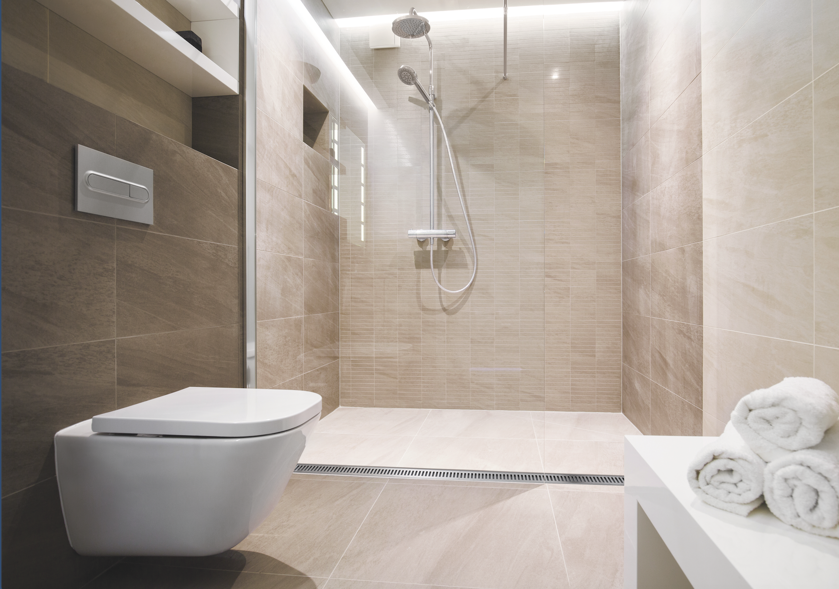
The multiple-SKU kit components and standardized options speed installation and minimize a renovation’s impact on customers, making the system especially popular among hospitality and healthcare remodeling projects that need to maximize their return on investment.
Contractors can select from several standard linear options and then order pre-sloped shower pan kits to achieve near-universal adaptability. Tile-ready and site-sizable pan kits enable installers to contend with a full-range of rough-in configurations, including above-the-floor, flush or at-the-surface, and through-the-floor or depressed waste connections. For professionals considering the time-saving system, the company offers a free initial shower pan trial (for any model room installed by a QuickDrain USA technician).
Affordable Tub-to-Shower Conversion Kits from QuickDrain can be easily customized to accommodate unexpected commercial plumbing and structural constraints.
Crafted with plumbing and design professionals in mind, the Tub-to-Shower Conversion Kits can be customized to fit nearly all shower enclosure sizes and conditions much more quickly and affordably than rigid one-piece acrylic or composite-shower pans.
Most important for institutional and facility owners is that these economical Tub-to-Shower Conversion Kits eliminate the need to access plumbing from the bathroom below, which not only inconveniences customers but impacts hotel revenue.
-more-
Tub-to-Shower Conversion Kit: Four Key Components
No two shower installations are exactly alike. That’s why the QuickDrain Tub-to-Shower Conversion Kit easily adapts to jobsite conditions. Four separate components comprise each conversion:
- Drain Body. The first step in specifying a tub-to-shower conversion is selecting the drain body. Multiple linear drain bodies, as well as several outlet configurations, are available, including
2" vertical, 2" side waste (90°), 1.5" vertical, and 1.5" side waste (90°). All drains can be adjusted on-the-jobsite after the drain body is installed to accommodate changes in height (via stackable leveling spacers) and width (via drain trough extensions.)
Offset or center waste-outlet drain bodies are particularly helpful when working in buildings constructed via post-tensioned slabs (to avoid the need for core drilling). Convenient drain trough extensions enable installers to move the drain body side-to-side to avoid any site-obstructions, while still providing wall-to-wall coverage recommended for efficient drainage.
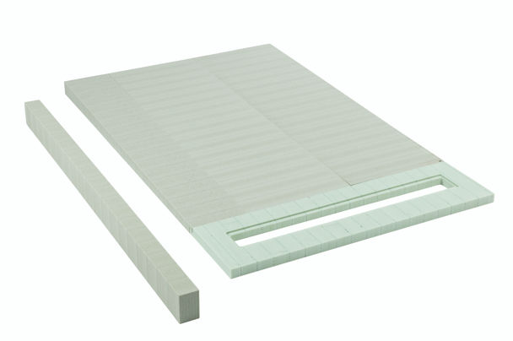
- Waterproofing System. Next, match the desired waterproofing system with the selected drain body. Tub-to-Shower Conversion Kits are compatible with either topical sheet waterproofing methods or topical liquid. The 78" wide Topical Sheet QuickLiner allows contractors to install a single waterproofing sheet, rather than piecing together multiple sheets to fit an enclosure. Pre-formed waterproofing inside/outside corner reinforcements, as well as curb covers, clamping collars and extension channels, add to the near-universal adaptability of the conversion kits.
Pre-sloped and tile-ready shower pan kits from QuickDrain USA are made from 100% recycled plastic and can be easily cut to accommodate jobsite irregularities.
- Shower Pan. After a waterproofing system is selected, a compatible shower pan is chosen. Contractors can use traditional, on-site, shower pan-construction techniques or opt for popular prefabricated options. Unlike conventional, pitched mud beds constructed over two-days, contractors using QuickDrain’s pre-sloped shower panels and waterproofing system can complete a shower modernization job in less than a day.
The QuickDrain Tub-to-Shower Conversion Kit includes support frames and pre-sloped floor panels to create a variety of curbed or curbless (zero-entry) enclosures. Each foam component can be easily cut and pieced together without the need for costly customization while eliminating the time and labor to float the typical pitched concrete shower base.
Comprised of extruded rigid PET (polyethylene terephthalate) plastic foam, the lightweight and shatterproof panels are constructed from 100% recycled plastic water bottles.
-more-
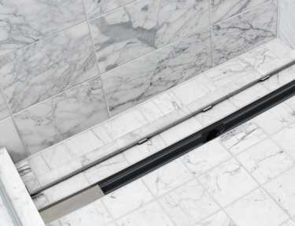

An advantage for architects and specifiers is that these recycled components may make an installation eligible for LEED certification points. The extruded PET foam panels are nonreactive and nondegradable, offering high performance even under the most demanding conditions.
A TileIn cover option is designed to accept an insert of the same shower tile to yield a drain that virtually “disappears.”

- Design-Matched Drain Covers. Finally, select among six decorative drain cover designs to accent the overall design scheme of any bath. Drain covers are available in multiple finish and ADA-compliant options and are constructed from durable 18 Gauge 304 Stainless Steel. A seventh drain cover is designed to accept an insert of the same tile or solid surface material used in the shower to yield a “TileIn” drain that virtually “disappears” in the floor.
Tub-to-Shower Conversion Kits from QuickDrain USA are the ideal and affordable choice for construction jobs that would otherwise require lengthy customizations due to varying rough-in conditions and structural constraints, including healthcare facilities or hospitality renovations.
For more information or assistance with drain design and installation, call 866-998-6685, or visit: http://www.quickdrainusa.com/solutions/market/hotel-shower-drains/tub-to-shower/
Hi-res versions of photography to accompany this release are available for immediate download by using this link: https://quickdrain.greenhousedigitalpr.com/tub-to-shower
# # #
100-WORD PRODUCT SUMMARY
Tub-to-Shower Conversion Kits from QuickDrain USA help contractors economically adapt to numerous commercial jobsite irregularities including unexpected plumbing configurations and structural constraints when constructing spa-like curbless or curbed showers for hospitality, healthcare and institutional applications. Contractors can select from among several linear drain bodies and multiple waste-outlet orientations together with pre-sloped pan kits to achieve near-universal adaptability. The multi-SKU Tub-to-Shower Conversion Kits affordably accommodate finished shower dimensions between 32 inches to 72 inches. Try one on us - the company offers a free initial shower pan trial (for any model room installed by a QuickDrain USA technician). See: www.quickdrainusa.com.
# # #

-more-

ABOUT QUICKDRAIN USA AND OATEY
Part of the Oatey family of brands, QuickDrain USA is a premier manufacturer of curbless and curbed shower solutions for showers and wet areas. Since 1916, Oatey has provided reliable, high-quality products for the residential and commercial plumbing industries. Today, Oatey operates a comprehensive manufacturing and distribution network to supply more than 6,000 products for professional builders, contractors, engineers and do-it-yourself consumers around the world. The company has successfully met customer needs for more than a century by offering innovative plumbing solutions that deliver results the first time. All Oatey products and brands are backed with the highest-quality technical and customer support programs in the industry.
Based in Cleveland, Ohio, Oatey has locations in the United States, Canada, Mexico and China. For more information, visit Oatey.com; call (800) 321-9532; or follow Oatey on Facebook, Twitter, LinkedIn or Instagram.

Contact:
Katherine Lehtinen
klehtinen@oatey.com

