QuickDrain ShowerLine Makes the Beauty
of Curbless Showers Attainable
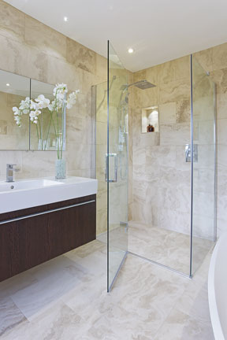
DENVER, June 5, 2019 — QuickDrain USA brings the spa-like luxury and high-end aesthetics to American home and facility owners everywhere with its ShowerLine linear shower drain. The drain’s high-end look and high-quality PVC construction allows designers and contractors to create stunningly beautiful showers without breaking the bank.
The ShowerLine linear drain from QuickDrain USA offers high-end style for both curbless and curbed showers without busting the budget.
Ideal for tub-to-shower conversions in single-family, hospitality and multi-family spaces, the drain system features a fully sloped trough where water exits through either a vertical or a side waste outlet, making it easy to accommodate existing plumbing. Seven separate stainless steel drain covers (available in brushed and polished finishes) compliment the economical, yet stylish series, ideal for both new and remodel applications.
It’s a perfect solution for both curbed and curbless showers, easily accommodating universal designs in accordance with the Americans with Disabilities Act.
Use of linear drains also offers labor savings, as installers need to only create a one-directional slope, compared with a conventional four-way compound slope used with center point drains. This improves drainage, giving water one uniform path to the drain, minimizing installation errors and hazardous standing-water “dead spots.”
The integrated PVC drain, combined with pre-sloped shower panels and waterproofing accessories, represents a total shower solution for promoting effective and efficient drainage. Other features of the ShowerLine drain include:
- On-site adjustability: Perfect for almost any existing plumbing application, stackable spacers allow installers to adjust the height of the drain cover to ensure it is flush with the shower floor. Likewise, trough extensions and covers may be trimmed onsite, after the PVC body is installed, making it easy to provide wall-to-wall coverage, which helps to minimize standing water or water traveling beyond the curbless shower entry.
-more-
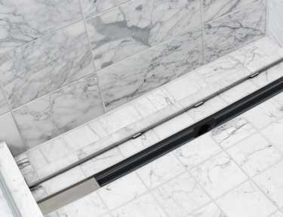

- Field flexibility: ShowerLine drains allow for the construction of accessible showers that do not have to be recessed into the floor. Instead, shower pans can be set flush to the subfloor, resulting in a great-looking curbed or curbless shower without the expense.
A TileIn cover option for the QuickDrain ShowerLine linear drain is designed to accept an insert of the same shower tile to yield a drain that virtually “disappears.”

- Lower maintenance: The ShowerLine drain can be integrated with larger format tiles, reducing the number of grout joints and seams where mold, mildew and grime can take hold. And, using large tiles throughout the room, from the floor into the shower, can make a small bath appear larger.
- Superior adaptability: ShowerLine can accommodate a poured shower pan or QuickDrain’s Quickslope PET (polyethylene terephthalate) rigid-foam shower floor panels. The latter is an environmentally friendly option, fabricated from recycled, plastic water and soda bottles, that also considerably reduces installation time and labor cost.
REMODEL READY
The transitional styling of ShowerLine lends itself to both traditional and contemporary décors. And, because ShowerLine doesn’t require the use of a two-piece clamping collar, this PVC linear drain allows for the rapid construction of curbless or curbed showers, with minimal impact to the subfloor. The system creates wall-to-wall coverage, promoting the effective and efficient drainage of water.
Michael Graves-DesignED CoverS
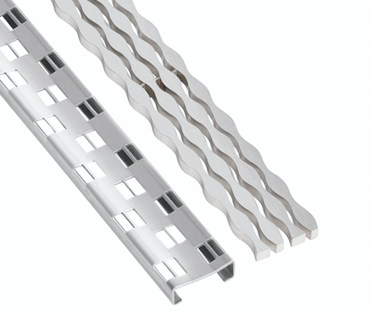

The late Michael Graves, one of the most prominent and prolific American architects of the late 20th century, felt that every home should have at least one curbless shower—and its affordability should not be a hurdle.
The Michael Graves-designed Cosmo (left) and Stream linear drain covers from QuickDrain USA are approved for curbed and curbless showers.
He collaborated with QuickDrain on two ADA compliant drain covers that reflect his iconic Postmodernism outlook. Grave’s Cosmo and Stream cover designs are crafted from durable 18-gauge, 304 stainless steel. The removable, slim-profile covers are both offered with a brushed stainless steel finish, while the Cosmo is also available in a polished stainless finish. Five additional cover designs round out the seven available options for the ShowerLine drain series, including a TileIn cover.
The TileIn option (photo above) is designed to accept an insert of the same tile or solid-surface material used in the shower to yield a drain that virtually “disappears” into the floor.
-more-

Key specifications: The ShowerLine drain body is made of PVC and is available in six standard sizes and four outlet configurations. ShowerLine drains accommodate finished shower dimensions between 32 inches and 72 inches. ShowerLine is ADA-compliant∗ and is Compliant with Uniform Plumbing Code, International Plumbing Code & ASME A112.18.2/CSA B125.2. List prices start at $225.

For more information or assistance with drain design and installation, call 866-998-6685, or visit: www.quickdrainusa.com/products/showerline.
Hi-res versions of photography to accompany this release are available for immediate download by using this link: https://quickdrain.greenhousedigitalpr.com/showerline.
# # #
80-WORD PRODUCT SUMMARY
Ideal for curbless showers and tub-to-shower conversions in single-family, hospitality and multifamily buildings, the ShowerLine PVC linear drain from QuickDrain USA offers a cutting-edge look and sleek design for projects with tight budgets. The integrated PVC drain, combined with pre-sloped shower panels and waterproofing accessories, represents a total shower solution for promoting effective and efficient drainage. The ADA-compliant and UPC-approved drain slashes installation time, saves on cost, and minimizes impact on customers. ShowerLine drains accommodate finished shower dimensions between 32 inches to 72 inches. Prices start at $225. See:
www.quickdrainusa.com.
# # #
ABOUT QUICKDRAIN USA AND OATEY
Part of the Oatey family of brands, QuickDrain USA is a premier manufacturer of curbless and curbed shower solutions. Since 1916, Oatey has provided reliable, high-quality products for the residential and commercial plumbing industries. Today, Oatey operates a comprehensive manufacturing and distribution network to supply more than 6,000 products for professional builders, remodelers, plumbing contractors, engineers and do-it-yourself consumers around the world. The company has successfully met customer needs for more than a century by offering innovative plumbing solutions that deliver results the first time. All Oatey products and brands are backed with the highest-quality technical and customer support programs in the industry.
Based in Cleveland, Ohio, Oatey has locations in the United States, Canada, Mexico and China. For more information, visit Oatey.com, call (800) 321-9532 or follow Oatey on Facebook, Twitter, LinkedIn or Instagram.

*Compliance is subject to installation as required by the applicable code and/or other jurisdictional requirements.

