QuickDrain ProLine Stainless Steel Linear Shower Drain
Ideal for Curbed or Curbless Showers
High-style, superior function and ease of installation drive ProLine’s appeal.

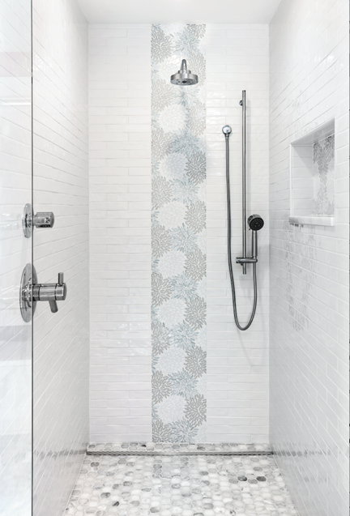
DENVER, APRIL 10, 2019 — The ProLine linear shower drain by QuickDrain USA offers minimalist style, impeccable performance and ease-of-installation to help interior designers and remodeling contractors create jaw-dropping, zero entry showers and wet areas that allow wheelchair access and ADA compliance.
Ideal for tub-to-shower conversions in hospitality, healthcare and luxury apartments, the ProLine linear drain from QuickDrain USA offers style, installation flexibility and impeccable drainage.
Ideal for tub-to-shower conversions in hospitality, healthcare and institutional spaces, the stainless steel drain features a fully sloped, one-inch deep and one-inch wide trough where water exits through either a vertical or a side waste outlet, making it easy to accommodate existing plumbing. The integrated drain, combined with pre-sloped shower panels and waterproofing accessories, represents a total shower solution for effective and efficient drainage.
Use of linear drains also offers cost and labor savings as installers need to create only a single slope, compared with a conventional four-directional slope used with center point drains. Eliminating the compound slope in the shower pan also opens up new opportunities for design, allowing users to create an uninterrupted flow from bathroom to shower with beautiful large format tile and solid surface materials.
Other features of the ProLine drain include:
- Field flexibility: ProLine drains allow for the construction of accessible showers that do not have to be recessed into the floor. Instead, shower pans can be set flush to the subfloor, resulting in a great looking curbed or curbless shower without the expense.
- Fully sloped drain trough: The drain’s fully sloped trough promotes efficient water drainage to minimize slip hazards and reduce mold, mildew and bacteria growth.
-more-
- On-site adjustability: Perfect for almost any existing plumbing application, stackable spacers allow installers to adjust the height of the drain cover to ensure it’s flush with the floor. Likewise, trough extensions and covers may be trimmed after the body is installed, providing wall-to-wall coverage.
- Superior adaptability: ProLine can accommodate a poured shower pan or QuickDrain’s own Quickslope PET (polyethylene terephthalate) rigid-foam panels. The latter is an environmentally friendly option, fabricated from recycled, plastic water and soda bottles, that also considerably reduces installation time and labor cost.
REMODEL READY
The transitional styling of ProLine lends itself to both traditional and contemporary décors. Applications encompass both residential and commercial spaces, including hospitality (hotels, resorts and casinos), as well as wet rooms in health facilities, nursing homes, dormitories and other barefoot areas, such as spa/pool surroundings and locker rooms.
Because ProLine easily connects to the existing drain line and doesn’t require the use of a two-piece clamping collar, this stainless steel linear drain allows for the rapid construction of curbless or curbed showers, with minimal impact to the subfloor. ProLine can be customized to adapt to various jobsite situations, including adding or upsizing outlets and customizing lengths. Trough extensions allow the drain body to extend wall-to-wall for full coverage, efficient drainage and a beautiful aesthetic.
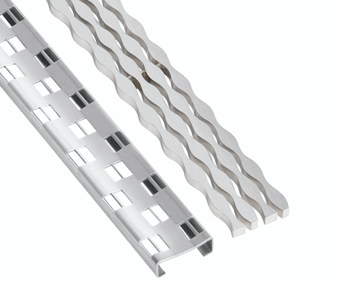
The Michael Graves-designed Cosmo (left) and Stream linear drain covers from QuickDrain USA are approved for curbed and curbless showers.

TROUGH SINKS & OUTDOOR DRAINS
The ProLine drain can also be used to create contemporary trough bathroom sinks. The Schedule 10 stainless steel sink drain length, including flanges, is 20-inches, while the finished length is 18-inches. In addition to sink drains, the ProLine is a great tool to create unique outdoor and pool applications, especially with a variety of decorative drain covers to complement every location.
Michael Graves Design CoverS
The late Michael Graves, one of the most prominent and prolific American architects of the latter 20th century, collaborated with QuickDrain on two drain covers that reflect his iconic Postmodernism outlook.
Grave’s Cosmo and Stream cover designs are crafted from durable 18 gauge or solid 304 stainless steel. Both are offered with a brushed stainless steel finish, while the Cosmo is also available in a polished stainless finish. The slim-profile covers are removable, per code, and available in sizes ranging from 32-inches to 72-inches.
Five additional cover designs round out the seven available options for the ProLine drain series. A TileIn cover option is designed to accept an insert of the same tile or solid surface material used in the shower to yield a drain that virtually “disappears.”
-more-
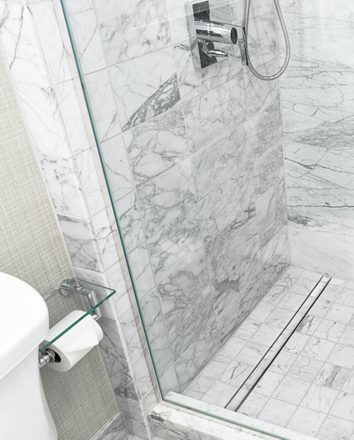
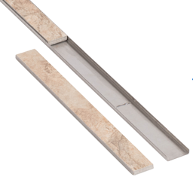
Key specifications: The ProLine linear drain features a 316L marine-grade stainless steel body. Standard drain sizes can range from 28-inches to 70-inches. ProLine drains accommodate finished shower dimensions between 32-inches and 72-inches, with custom options available between 10-inches and 100-inches. The drain can accommodate site-specific conditions, including options for custom waste outlet lengths, offset outlet locations and multiple waste outlets. ProLine is ADA-approved and is Compliant with Uniform Plumbing Code, International Plumbing Code & ASME A112.18.2/CSA B125.2. List prices start at $750.
Tile insert drain covers from QuickDrain USA are designed to accept the same tile or solid surface material used in the shower to yield a drain that virtually “disappears.”
For more information on ProLine or assistance with drain design and installation, call 866-998-6685, or visit: quickdrainusa.com/products/proline
Hi-res versions of photography to accompany this release are available for immediate download by using this link: https://quickdrain.greenhousedigitalpr.com/proline
# # #
80-WORD PRODUCT SUMMARY
Ideal for tub-to-shower conversions in hospitality, healthcare and luxury master baths, the ProLine linear drain from QuickDrain USA offers cutting-edge style, installation flexibility and impeccable drainage. The integrated drain, combined with pre-sloped shower panels and waterproofing accessories, represents a total shower solution for promoting effective and efficient drainage. The ADA-compliant and UPC-approved drain slashes installation time, saves on cost, and minimizes impact on customers. ProLine drains accommodate finished shower dimensions from 32-inches to 72-inches. Prices start at $750. See: www.quickdrainusa.com/
# # #
ABOUT QUICKDRAIN USA AND OATEY
Part of the Oatey family of brands, QuickDrain USA is a premier manufacturer of curbless and curbed shower solutions. Since 1916, Oatey has provided reliable, high-quality products for the residential and commercial plumbing industries. Today, Oatey operates a comprehensive manufacturing and distribution network to supply more than 6,000 products for professional builders, contractors, engineers and do-it-yourself consumers around the world. The company has successfully met customer needs for more than a century by offering innovative plumbing solutions that deliver results the first time. All Oatey products and brands are backed with the highest-quality technical and customer support programs in the industry.
Based in Cleveland, Ohio, Oatey has locations in the United States, Canada, Mexico and China. For more information, visit Oatey.com, call (800) 321-9532 or follow Oatey on Facebook, Twitter, LinkedIn or Instagram.

